Conversion Analysis Report

- Introduction:
This report analyses transaction data across multiple stores and SKUs to identify key trends and provide actionable recommendations. The objective is to improve overall sales performance by analysing store-level and SKU-level conversion rates.

Tasks:
1: Below is the Link Updated File of the conversion rate at both the store level and the SKU level: Updated File Click Here

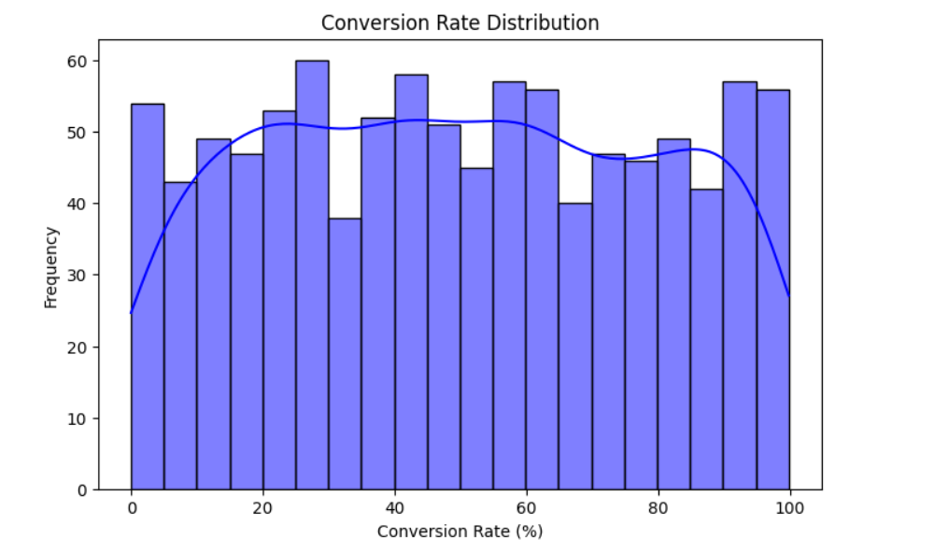

2: Data Analysis:

* Store-Level Conversion Analysis:
Top 5 Performing Stores:

Store ID Total_Visits Total_Trans Total_Revenue Conversion_Rate
Store_39 9213 6124 667804.09 66.471291
Store_49 11032 7129 793523.76 64.621102
Store_44 8482 5356 467371.06 63.145485
Store_37 9458 5937 404139.26 62.772256
Store_47 9753 6081 521435.76 62.350046

Bottom 5 Performing Stores:

Store ID Total_Visits Total_Trans Total_Revenue Conversion_Rate
Store_12 8698 3310 313714.85 38.054725
Store_30 10659 4043 388411.83 37.930387
Store_36 10149 3819 431669.84 37.629323
Store_14 12804 4674 421539.55 36.504217
Store_15 8922 3090 362021.48 34.633490
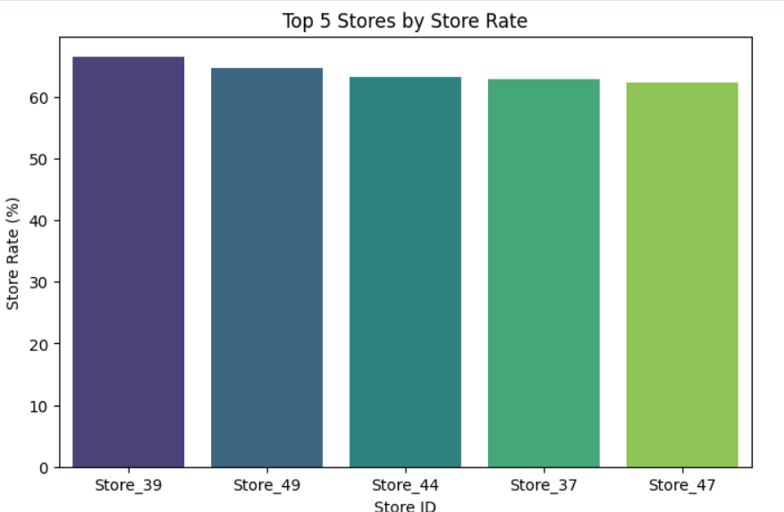

* SKU-Level Conversion Analysis SKU-Level Conversion Analysis

Top 5 Performing SKUs:

SKU ID Total_Visits Total_Trans Total_Revenue Conversion_Rate

SKU_11 27856 16323 1665863.73 58.597789
SKU_7 26103 14654 1674024.12 56.139141
SKU_16 23574 12906 1234789.51 54.746755
SKU_4 24782 13505 1370489.58 54.495198
SKU_9 26715 14324 1284551.61 53.617818

Bottom 5 Performing SKUs:

SKU ID Total_Visits Total_Trans Total_Revenue Conversion_Rate

SKU_17 25295 11511 1313362.41 45.507017
SKU_8 25163 11447 1205717.50 45.491396
SKU_20 25224 11387 1165791.42 45.143514
SKU_19 25834 11440 1170544.47 44.282728
SKU_12 27687 11569 1222730.98 41.784953

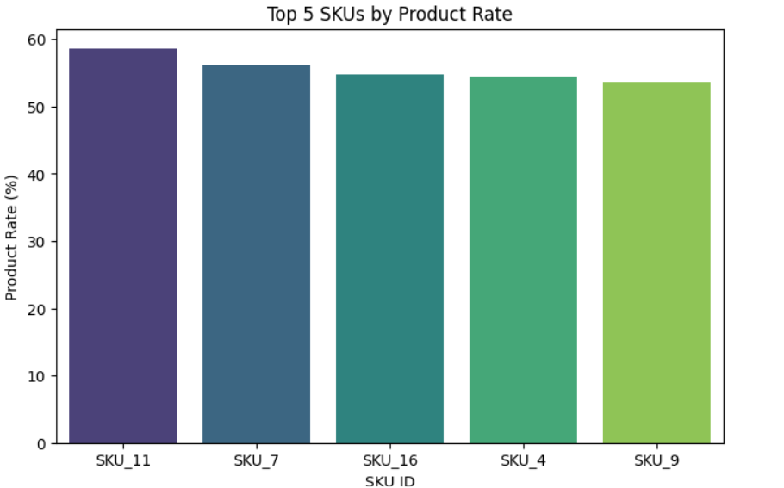

Key Trends Related to Store and SKU Performance:
1: High Conversion in Top Stores:
Top_performing stores (e.g., Store_39: 66.47%) exhibit significantly higher conversion rates due to optimized operations or targeted strategies.
2: Large Gap between Top and Bottom Stores:
Conversion rates drop from 66.47% (Store_39) to 34.63% (Store_15), indicating scope for improvement in underperforming stores.
3: Consistent SKU-Level Performance:
Top SKUs (e.g., SKU_11: 58.60%) maintain strong conversion rates, while the gap between the top and bottom SKUs is narrower, suggesting more uniform SKU performance.

Summary

The data analysis reveals significant patterns in both store-level and SKU-level performance. At the store level, the top-performing stores, such as Store_39 and Store_49, achieve conversion rates exceeding 64%, with Store_39 leading at 66.47%. These stores excel at turning customer visits into transactions, indicating effective operations, marketing, or customer engagement strategies. In contrast, underperforming stores like Store_15 and Store_14 show conversion rates below 37%, with Store_15 at 34.63%. This highlights a substantial performance gap, as the top stores convert visitors at nearly double the rate of the lowstperforming ones. Addressing inefficiencies in these stores presents an opportunity to unlock untapped revenue potential.

At the SKU level, top_performing products, such as SKU_11 and SKU_7, boast conversion rates of 58.60% and 56.14%, respectively, while also generating substantial revenue. These SKUs are likely in high demand, driven by factors like quality, pricing, or effective positioning. On the other hand, underperforming SKUs like SKU_12 and SKU_19 have lower conversion rates, hovering around 41.78%. However, the gap between top and bottom SKUs is narrower than that of stores, suggesting more consistent SKU_level performance overall. Improving the appeal of underperforming SKUs and replicating the strategies of top-performing ones can drive overall revenue growth.

To summarize, focusing on underperforming stores and SKUs, while leveraging the best practices of high performers, can significantly enhance overall performance. Regular monitoring of conversion rates and targeted interventions are crucial to closing the performance gaps and maximizing revenue.
SriMandir today has multiple business lines - Puja, Chadhava, Commerce, Travel and astro. Team today has only one PA taking care of all data requirements. If entrusted with the task of designing the ideal team structure for the data team (business analysts/PAs/data analysts) how would you go about it?
To handle SriMandir's diverse business lines, a centralized data team is recommended. Assign one Business Analyst (BA) and one Data Analyst per line (Puja, Chadhava, Commerce, Travel, Astro) for domain-specific insights. Add a Data Engineer for infrastructure and pipelines, and a Data Lead to oversee operations. This structure ensures scalability, efficiency, and tailored analytics for each business line.

